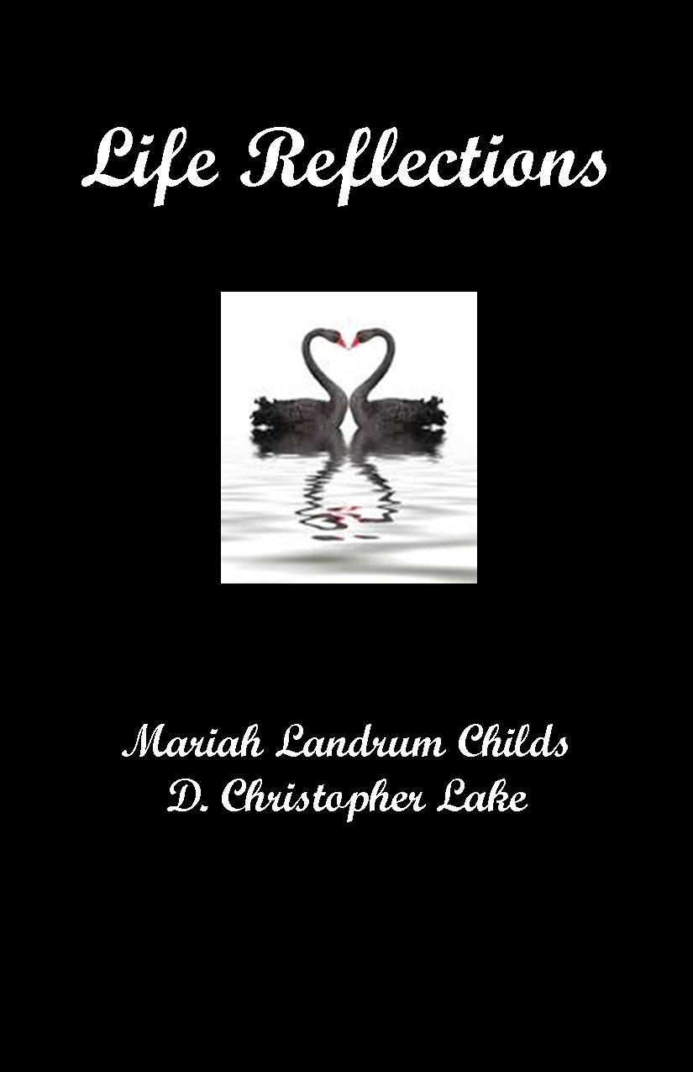

LIFE REFLECTIONS
Mariah Landrum Childs & D. Christopher Lake
Pages: 148
Dimensions: 7 x 7
Category: RELIGION- Christian General
Type:
Paperback
ISBN: 0-9764895-8-9
Price: $13.99

BOOK SUMMARY

• Are you feeling weary in your mind, body and spirit?
• Do you feel anxious about growing old?”
• Enjoy reading seniors’ life reflections as you ruminate over your own.

“For everything there is a season, a time for every activity under heaven. A time to be born and a time to die. A time to plant and a time to harvest…A time to cry and a time to laugh. A time to grieve and a time to dance” (Ecclesiastes 1-2, 4 NLT).

LIFE REFLECTIONS is filled with the personal reflections of elders written to share their memories of the way things used to be with the younger generation through recalling special events and people in their lives. It opens up channels for dialog and communication between elders, their family members and caretakers. It provides elders with the opportunity to share and deposit their “collective wisdom” as living legacies for family members and caretakers. Elderly who have fears about their mortality will find encouragement and empathy. Caretakers will gain insights and strength to empower them as they care for the elderly whether they live independently and need minimal care or need more intensive care and live in residential facilities or in the homes of their children or other family members.

