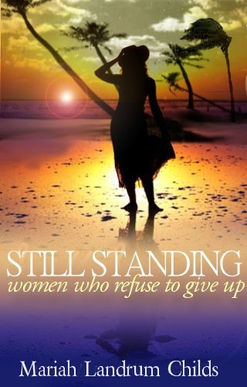
Still Standing women who refuse to give up
Mariah Landrum Childs
Pages: 210
Dimensions: 5 ¼ x 8 ¼
Category: RELIGION- Christian General
Type:
Paperback
ISBN: 0-9764895-9-7
Price: $13.99

BOOK SUMMARY

• Tired of being tossed to and fro by the storms of life?
• Feel like “tossing in the towel?”
• Learn how to “stand” from women who know how.

“Therefore put on the full armor of God, so that when the day of evil comes, you may be able to stand your ground, and after you have done everything, to stand” (Ephesians 6:13 NIV).

STILL STANDING Women Who Refuse to Give Up is an anthology of Christian women’s testimonies demonstrating God’s faithfulness to give them the necessary fortitude to keep standing—even when their minds, bodies and spirits want to “give up.” These women, through their personal stories, share how God met them at the point of their greatest need. Each learned through personal experience that no matter how fierce the waves of adversity may buffet against them, or how high their problems may billow—the Lord is a very present help in the time of trouble!

